SMART CARE: MULTILINGUAL SYMPTOM MAPPER AND DRUG ANALYZER
ABSTRACT:
Healthcare information is often difficult for patients to understand due to handwritten prescriptions, complex medical terminology, language barriers, and limited awareness of medicine safety. Many people struggle to identify their prescribed medicines, follow dosage instructions correctly, or recognize possible drug interactions and allergies. To address these challenges, this project proposes Smart Care: Multilingual Symptom Mapper and Drug Analyzer, an AI-powered mobile application that simplifies healthcare information and assists users in managing their daily health.The application allows users to create a personal health profile containing details such as age, height, weight, existing medical conditions, allergies, and ongoing medications. Using Optical Character Recognition (OCR), the system scans handwritten prescriptions and extracts medicine names, which are then translated into multiple languages including English, Tamil, Kannada, and Hindi. The application explains the purpose and usage of each medicine in simple, easy-to-understand language and performs safety checks by comparing prescriptions with the user's health profile using medical reference databases such as openFDA to detect potential drug interactions, allergy risks, and inappropriate dosage warnings.Smart Care also includes an AI-based symptom mapping module where users can identify the affected body part using an interactive body model, describe symptoms through text or voice in their native language, and receive basic health guidance through an intelligent conversational assistant. Additionally, users can upload images of common skin conditions such as rashes or redness for a preliminary educational assessment using image analysis techniques. The application further enhances preventive healthcare by providing personalized meal recommendations based on health conditions and allergies, monitoring health parameters through smartwatch integration, and delivering medicine, hydration, and wellness reminders.In emergency situations, such as symptoms indicating severe chest pain or breathing difficulty, the application quickly provides nearby hospitals, doctors, and emergency contact information while reminding users to seek immediate professional medical assistance. Overall, Smart Care serves as an intelligent digital healthcare companion that combines Artificial Intelligence, OCR, multilingual translation, medical knowledge, voice assistance, and health monitoring to improve healthcare accessibility, promote medication safety, and support informed health management. The application is designed as an educational and supportive tool and is not intended to replace diagnosis or treatment provided by qualified healthcare professionals.

INTRODUCTION:
Healthcare is one of the most important aspects of human life, but understanding medical information remains a major challenge for many people. Patients often receive handwritten prescriptions that are difficult to read and contain complex medical terminology that is not easily understood by non-medical individuals. This problem becomes even more serious for elderly people, rural populations, and individuals who are not familiar with the English language. Misunderstanding medicine names, dosage instructions, or treatment plans can lead to incorrect medication usage, delayed recovery, and serious health complications. Therefore, there is a growing need for an intelligent healthcare solution that can simplify medical information and make it accessible to everyone.With the rapid growth of Artificial Intelligence (AI), Machine Learning (ML), Optical Character Recognition (OCR), Natural Language Processing (NLP), and mobile technologies, it has become possible to build smart healthcare applications that assist users in understanding their medical information. AI-powered healthcare systems can analyze prescriptions, identify medicines, explain their purpose in simple language, translate instructions into regional languages, and provide health-related guidance. These technologies improve healthcare accessibility while reducing communication barriers between doctors and patients.The proposed project, Smart Care: Multilingual Symptom Mapper and Drug Analyzer, is an AI-based mobile application developed to provide users with a simple, safe, and interactive healthcare experience. The application acts as a digital health assistant by combining prescription analysis, multilingual translation, symptom mapping, medicine safety checking, food recommendations, smartwatch health monitoring, and emergency support into a single platform. It is designed to help users better understand their health conditions and medicines without requiring medical expertise.The first module of the application allows users to create a personal health profile by entering details such as age, height, weight, allergies, existing diseases, and current medications. This information is securely stored and used to provide personalized healthcare recommendations. The application also helps users maintain a healthy lifestyle by tracking daily water intake and reminding them to take medicines on time.One of the key features of Smart Care is the Prescription Scanner. Users simply capture an image of a doctor's handwritten prescription using their mobile phone camera. OCR technology extracts the medicine names and prescription details from the image. The system then explains the purpose of each medicine using simple language instead of complicated medical terminology. It also translates the prescription into English, Tamil, Kannada, or Hindi, making healthcare information understandable for users who prefer their native language.The Drug Safety Analyzer improves patient safety by comparing prescribed medicines with the user's health profile. Using reliable medical databases such as openFDA, the application checks for possible drug interactions, allergy risks, and dosage-related warnings based on the user's age, weight, allergies, and current medications. If any potential problem is detected, the system immediately alerts the user and recommends consulting a qualified healthcare professional before taking the medicine.Another important feature is the AI-based Symptom Checker. Instead of typing lengthy descriptions, users can simply tap the affected body part on an interactive body model and select their pain level. The AI assistant asks simple follow-up questions through text or voice conversations to understand the symptoms better. Based on the collected information, the application provides educational guidance about possible health conditions while clearly informing users that it does not replace professional medical diagnosis.The application also supports basic skin condition analysis by allowing users to upload images of skin rashes, redness, or allergies. Image processing and deep learning techniques perform a preliminary assessment and provide general educational information. This feature encourages users to seek timely medical attention if the condition appears serious.To promote healthy living, Smart Care offers personalized meal recommendations based on the user's health conditions and allergies. For example, it recommends low-salt diets for heart patients, low-sugar foods for diabetic patients, and avoids foods that may trigger allergic reactions. The application also connects with wearable smart devices to monitor heart rate, blood oxygen level, stress level, physical activity, and sleep patterns. These health metrics help users monitor their overall well-being more effectively.
The application further includes medicine reminders, water intake notifications, daily health tips, and myth-versus-fact educational content to improve health awareness. In emergency situations, such as severe chest pain or breathing difficulty, Smart Care immediately displays nearby hospitals, available doctors, and emergency contact numbers so that users can quickly access professional medical care.The backend of the application is developed using Python-based frameworks such as Flask or FastAPI, while the frontend can be built using Flutter for cross-platform mobile support. OCR libraries such as EasyOCR or Tesseract are used for prescription reading, translation services convert medical instructions into multiple languages, and AI models support symptom analysis and image-based health assessment. Medical references are obtained from trusted healthcare databases to ensure reliable safety warnings.Overall, Smart Care is designed as a comprehensive digital healthcare assistant that combines Artificial Intelligence, OCR, multilingual translation, voice assistance, wearable device integration, and medical knowledge into a single mobile application. The system aims to improve healthcare accessibility, increase medicine safety, reduce language barriers, and help users make informed health decisions. Although the application provides educational guidance and personalized recommendations, it clearly reminds users that it is not a substitute for professional medical advice, diagnosis, or treatment from qualified healthcare providers.

OBJECTIVE:
The primary objective of the Smart Care: Multilingual Symptom Mapper and Drug Analyzer project is to develop an AI-powered mobile application that helps users understand medical prescriptions, medicines, and health conditions in a simple and user-friendly manner. The system aims to improve medication safety by detecting possible drug interactions, allergy risks, and dosage warnings while providing multilingual support for better accessibility. It also assists users in monitoring their daily health, receiving personalized food recommendations, and obtaining educational health guidance through intelligent symptom analysis and voice-based interaction.

PROBLEM STATEMENT:
Many patients face difficulties in understanding handwritten prescriptions, complex medical terminology, and medicine instructions, particularly when they are not familiar with the English language. Incorrect interpretation of prescriptions, lack of awareness about drug interactions, and limited access to reliable healthcare information can lead to medication errors and delayed treatment. Therefore, there is a need for an intelligent multilingual healthcare application that simplifies medical information, promotes safe medicine usage, and provides basic health guidance while encouraging users to seek professional medical care whenever necessary.

EXISTING SYSTEM:
A commonly used approach in IEEE research for medical text understanding is the BERT (Bidirectional Encoder Representations from Transformers) model, which is used to identify medicine names, diseases, and clinical terms from electronic medical records and digital prescriptions. The model provides high accuracy in extracting medical entities from typed healthcare documents and assists in organizing clinical information. However, these systems are mainly designed for structured digital medical records and do not provide complete patient assistance such as multilingual translation, symptom mapping, medicine reminders, or wearable device integration.
DISADVANTAGES:
- handwritten prescriptions
- limited multilingual support,
- drug-allergy checking, symptom mapping

PROPOSED SYSTEM:
The proposed system, Smart Care: Multilingual Symptom Mapper and Drug Analyzer, is an AI-powered mobile application that integrates OCR, Natural Language Processing, Machine Learning, multilingual translation, and medical knowledge databases to simplify healthcare information for users. The application scans handwritten prescriptions, explains medicines in simple language, performs drug interaction and allergy safety checks, provides AI-based symptom analysis, supports voice interaction in multiple languages, and offers personalized food recommendations and smartwatch-based health monitoring. This integrated approach improves healthcare accessibility, medication safety, and user awareness while providing educational guidance without replacing professional medical advice.

ADVANTAGES:
- handwritten prescription scanning
- drug interactions, allergy risks, and dosage warnings
- AI symptom checking, smartwatch health monitoring

SYSTEM ARCHITECTURE:
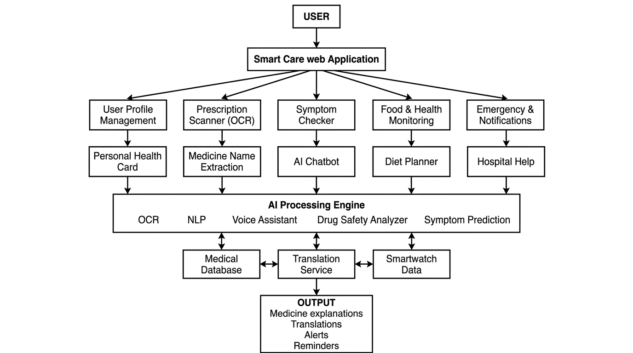

SOFTWARE REQUIREMENTS:
Component | Specification
Operating System | Windows 10/11, Linux, or macOS
Backend | Python 3.10 AND Anaconda Prompt
OCR Library | EasyOCR or Tesseract OCR
Machine Learning | Scikit-learn
Deep Learning | TensorFlow / PyTorch
Image Processing | OpenCV
NLP & AI | Transformers, NLTK, spaCy
Translation | Google Translate API / IndicTrans2
Voice Processing | SpeechRecognition, gTTS / pyttsx3

HARDWARE REQUIREMENTS:
- Processor :Intel Core i3/i5 or AMD Ryzen 3/5
- RAM :Minimum 4 GB (8 GB Recommended)
- Hard Disk :20 GB Free Space

REFERENCE:
1. Salmond, S.W.; Echevarria, M. Healthcare Transformation and Changing Roles for Nursing. Orthop Nurs 2017, 36, 12–25. [CrossRef]
2. Anderson, G. Chronic Conditions: Making the Case for Ongoing Care. Partnersh. Solut. Johns Hopkins Univ. 2002. Available online: https://www.policyarchive.org/handle/10207/21756 (accessed on 18 December 2023).
3. Li, J.; Porock, D. Resident Outcomes of Person-Centered Care in Long-Term Care: A Narrative Review of Interventional Research. Int. J. Nurs. Stud. 2014, 51, 1395–1415. [CrossRef]
4. Calvert, M.; Kyte, D.; Price, G.; Valderas, J.M.; Hjollund, N.H. Maximising the Impact of Patient Reported Outcome Assessment for Patients and Society. BMJ 2019, 364, k5267. [CrossRef]
5. Nguyen, H.; Butow, P.; Dhillon, H.; Sundaresan, P. A Review of the Barriers to Using Patient-Reported Outcomes (PROs) and Patient-Reported Outcome Measures (PROMs) in Routine Cancer Care. J. Med. Radiat. Sci. 2021, 68, 186–195. [CrossRef] [PubMed]
6. Black, N. Patient Reported Outcome Measures Could Help Transform Healthcare. BMJ 2013, 346, f167. [CrossRef] [PubMed]
7. Greenhalgh, J. The Applications of PROs in Clinical Practice: What Are They, Do They Work, and Why? Qual. Life Res. 2009, 18, 115–123. [CrossRef] [PubMed]
8. Snyder, C.F.; Aaronson, N.K.; Choucair, A.K.; Elliott, T.E.; Greenhalgh, J.; Halyard, M.Y.; Hess, R.; Miller, D.M.; Reeve, B.B.; Santana, M. Implementing Patient-Reported Outcomes Assessment in Clinical Practice: A Review of the Options and Considerations. Qual. Life Res. 2012, 21, 1305–1314. [CrossRef]
9. Churruca, K.; Pomare, C.; Ellis, L.A.; Long, J.C.; Henderson, S.B.; Murphy, L.E.D.; Leahy, C.J.; Braithwaite, J. Patient-Reported Outcome Measures (PROMs): A Review of Generic and Condition-Specific Measures and a Discussion of Trends and Issues. Health Expect. 2021, 24, 1015–1024. [CrossRef] [PubMed]
10. Foster, A.; Croot, L.; Brazier, J.; Harris, J.; O’Cathain, A. The Facilitators and Barriers to Implementing Patient Reported Outcome Measures in Organisations Delivering Health Related Services: A Systematic Review of Reviews. J. Patient-Rep. Outcomes 2018, 2, 46. [CrossRef] [PubMed]
11. Ju, A.; Tong, A. Considerations and Challenges in Selecting Patient-Reported Outcome Measures for Clinical Trials in Nephrology. Clin. J. Am. Soc. Nephrol. 2017, 12, 1882–1884. [CrossRef]
12. Montgomery, N.; Bartlett, S.J.; Brundage, M.D.; Bryant-Lukosius, D.; Howell, D.; Ismail, Z.; Krzyzanowska, M.K.; Moody, L.; Snyder, C.F.; Staley Liang, M.; et al. Defining a Patient-Reported Outcome Measure (PROM) Selection Process: What Criteria Should Be Considered When Choosing a PROM for Routine Symptom Assessment in Clinical Practice? J. Clin. Oncol. 2018, 36, 187. [CrossRef]
13. Keller, S.; Dy, S.; Wilson, R.; Dukhanin, V.; Snyder, C.; Wu, A. Selecting Patient-Reported Outcome Measures to Contribute to Primary Care Performance Measurement: A Mixed Methods Approach. J. Gen. Intern. Med. 2020, 35, 2687–2697. [CrossRef] [PubMed]
14. Patients’ Reasons for Non-Use of Digital Patient-Reported Outcome Concepts: A Scoping Review—Amalie Søgaard Nielsen, Kristian Kidholm, Lars Kayser, 2020. Available online: https://journals.sagepub.com/doi/full/10.1177/1460458220942649 (accessed on 26 October 2023).
15. Calvert, M.J.; Cruz Rivera, S.; Retzer, A.; Hughes, S.E.; Campbell, L.; Molony-Oates, B.; Aiyegbusi, O.L.; Stover, A.M.; Wilson, R.; McMullan, C.; et al. Patient Reported Outcome Assessment Must Be Inclusive and Equitable. Nat. Med. 2022, 28, 1120–1124. [CrossRef] [PubMed]

